1. A Boolean value is either true or false.

Expressions resulting in a Boolean value:

>>> 6 == (2 + 4)

True

>>>6 == 10

False

>>> i = “b”

>>> i + “ye” == “bye”

True

1. Flowchart is a diagrammatic representation of an algorithm.

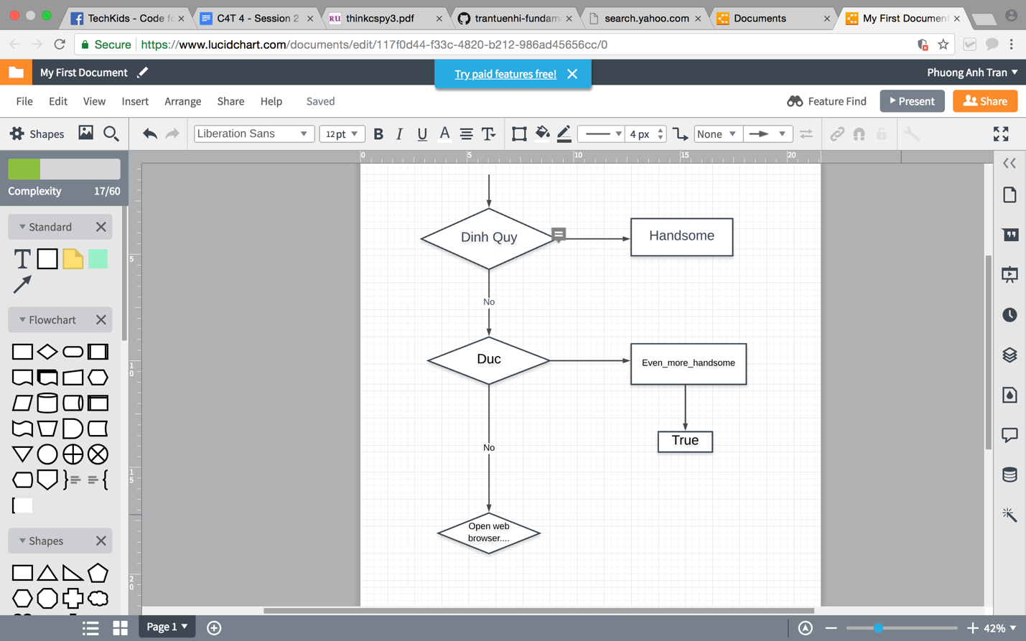

1. ‘Nested conditionals’ means that one condition can also be nested within another.

Code using nested conditionals:

1. if 0 < x:
2. statement_a
3. else:
4. if 0 > x:
5. statement_b
6. else:
7. statement_c